DESCISION MAKING

Telecommunication: the transformation of data through a distance in the form of electromagnetic signal to on another respective end

q) WHY YOU CHOOSE THE COMPUTER SCIENCE

ANS = WHAT I UNDERSTANS SIR THAT, THERE IS NO REQUIRMENT OF ANY SUBJECT TO BECOME AN COMPUTER SCIENCE

IRRESPECTIVE OF ANY BRANCH COMP SCI CAN BE IMPLEMENTED

PROPER ANALYTICS = ETL TESTING = DECISION MAKING

QULITY FACTORS:

1) COUSTMER REQUIRMANT

2) COUSTMER EXPECTATION

THS TWO FACTOR ARE INMPORTANT IN TESTING PROSPECTIVE

3) PRICE OF SOFTWERE

4) TIMELY DELIVERABLE

5) RISK MANAGMANT: IF SOME PROBLEM COMES THEN HOW TO SOLVE IT

SQA = software quality assurance: is to solve the issue from start to end avoid delays on target and quality of software. The SQA process going along with SDLC where they routinely check the software to ensure that it meets the desired quality measures

to monitor and measure the strength of dev team

a software related issue solved by software engineer through a software process

SDLC = Software developer life cycle

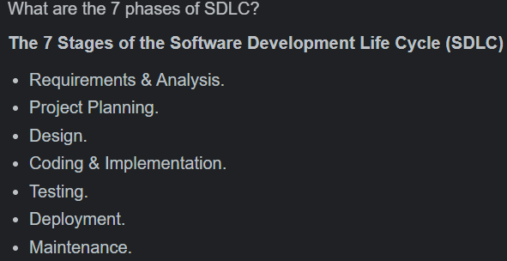

## COUSTMER REQUIRMENT:

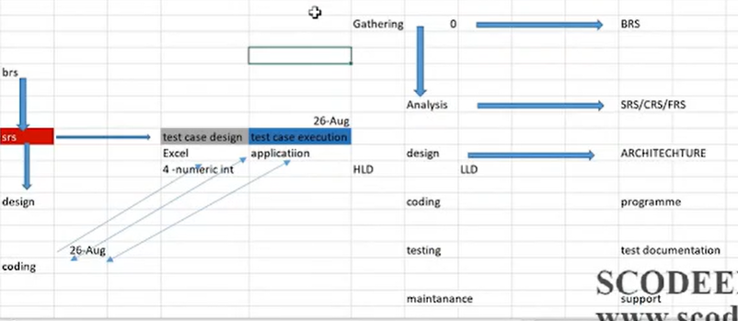

Graphical representation of SDLC:

If we analyse the graphical representation of SDLC, i.e., fish model first the SRS and BRS will be reviewed then the design coding will be reviewed

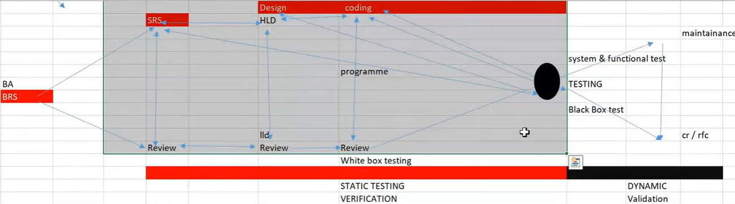

SRS (requirement)is nothing but analysis (junction area) one copy is sent to developer and another is sent to Tester

Once we receive the SRS document the development and testing process start simultaneously

Q) Why developer and tester and not seat beside each other?

Ans =

Q) What is SRS document?

ANS = 1) what the software will do

2) how it will perform

Q) What is the difference bet separate review of each section and end testing?

Ans = review testing is a static verification and testing is dynamic validation testing

Q) what is the difference between verification and validation?

Ans = Verification is a process of determining if the software is designed and developed as per the specified requirements.

Validation = Validation is the process of checking if the software (end product) has met the clien t's true needs and expectations

# System and function: one system countian many component->module ->submodule->element->attributes

Q) what is white box testing?

Ans= it is an approach that allows the tester to inspect and verify the inner working of software

system (transparency) after completion of code design developer reviews the code for correctness and completeness it is also known as clear box testing and glass box testing

developer follows two-dimensional approach

design = high level design

Grey box testing: a black box tester who is having knowledge on internal structure

Red box testing: (protocol testing = for telecom domain) a black box tester who deals with the network is called as red box testing

Q) what is static and dynamic testing?

Ans = static testing – 1) software application is tested without code execution

2) manual and automated review of code, document requirement and document design is used to find the error in early stages

It is done by developer

If we analyse the SDLC BA will review their own document, designer will review their own document, programmer will review their own document but we are responsible for to test the function of whole system, I mean to say irrespective of any stages if any defect is there, we will responsible for to catch the defect

Dynamic testing- 1) code is executed and checking of functional behaviour of software

System and overall performance

2) main objective is the software application is working properly or not

## DEFECTS

### SRS defect:

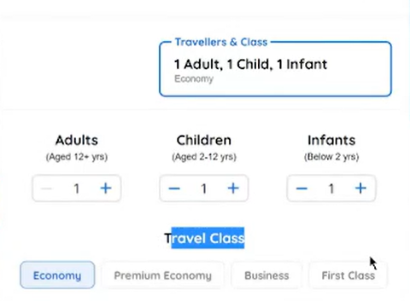

In the above example if we choose one adult or one child the respective app still shows the children, i.e., (plural) which must be in the below format

Child(ren) or adult(s)

This an SRS defect

2) DESIIGN DEFECT:

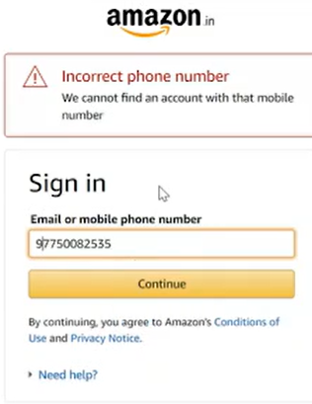

In the above scenario there must be selectively option for the phone number and email

There should not be the static and dynamic data in same text tab if it is still there the how come we can measure the length 0f the data. The length of the mail and phone no is different

So, we to test the scenario in three-dimensional approach

Static testing is stage of white box testing which called as dry run test

Q) if white box test reviews the code, then what black box testing do?

Ans = white box testing obeys two-dimensional approach and black box testing obeys three-dimensional approach

During the white box test the dev check the presence of defect in code

During the black box test the tester check the presence of defect in code as well as absence of defect in code that is positive and negative condition

What we understand here without verification the validation the quality software is not possible

Q) are you involved in white box testing?

Ans = yes sir I have involved in data intelligence implementation ------------------------------------------------ it means we are involving in white box testing in automation we have to write the code

Q) what is two and three-dimensional approach?

Ans= suppose the requirement is of 10-digit cell, Here the 10 digit is first-dimension and the it should be numeric it is second-dimensional approach and third-dimension is that it should countian string value, float, alphanumeric (@) and special character

Three-dimensional means implementation of business logic

Q) what is 3nf?

Ans= the purified data

BRS = Business requirement specification (done by BA)

Q) what is the basic requirement that are included in BRS?

ANS = This document defines the requirement of costumer to be developed as software it acts as bridge between costumer and technical candidates

SRS: Software requirement specification BA is responsible to design the SRS

FRS: Functional requirement specification

CRS: Customer requirement specification

The SRS document is design with help of BRS

SRS defines functional requirement to be developed and system requirement to be used

Functional requirement

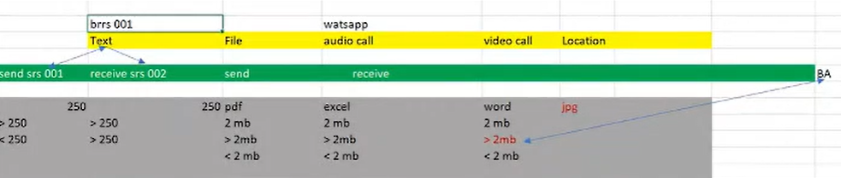

FUNCTIONS:

ADD - ADDRESS

COUNTRY

NAME

ZIP CODE

EDIT - ADDRESS

ADDRESS

COUNTRY

NAME

ZIP CODE

MODIFIY - ADDRESS

ADDRESS

COUNTRY

NAME

ZIP CODE

Application + server = system

q) WHAT IT CONSIST (SRS)?

ANS

1) functional requirement

2) use case: business condition

3) functional flow diagram

4) flow chart

5) environmental detail

6) prototypes = a sample module of application without functionality

1) functional requirement: It defines the function of system or its component, where function is describes as specification behaviour between input and output

It defines the functional requirement of system and I think it also will help to create relationship between input, whatever input we will give as it will show us sum result as output

2) use case business condition:

LOG IN IS FUNCTION

AID, PASSWORD

uc1: end user can enter the data. length max = 8

uc2: end user can enter the pass. length max = 5

uc3: if valid successful message else error message

--------------------------------------------------------

UC1: END USER CAN ENTER THE DATA. LEGTH MAX = 8

TEXT BOX: MIN =1, MAX = 8, IF BALNK ERROR MESSAGE

-----------------------------------------------

UC2: END USER CAN NETER THE PASS. LEGTH MAX = 5

TEXT BOX: MIN = 1, MAX = 8, BLANK - ERROR MESSAGE, ENCRYPTED

-----------------------------------------------

C3: IF VALID SUUCEFULL MESSAGE ELSE ERROR MESSAGE

COUNDITION

AID PASS STATUS

Y Y SUCCES

Y N FAIL

N Y FAIL

N N FAIL

BLANK BLANK FAIL

=================================================

## FUNCTINAL FLOW DIGRAM:

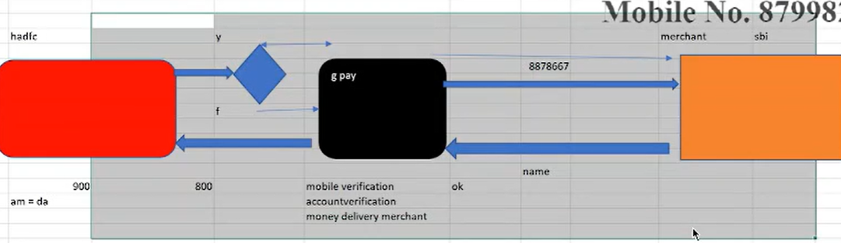

Here the first action is when you put the number of any Marchant then the merchant bank server sends the merchant’s name in back response, after receiving the name you pay the amount then the paid amount request is sent to the buyer bank server, then the verification of amount is done and then the merchant get his payment

## Flow chart:

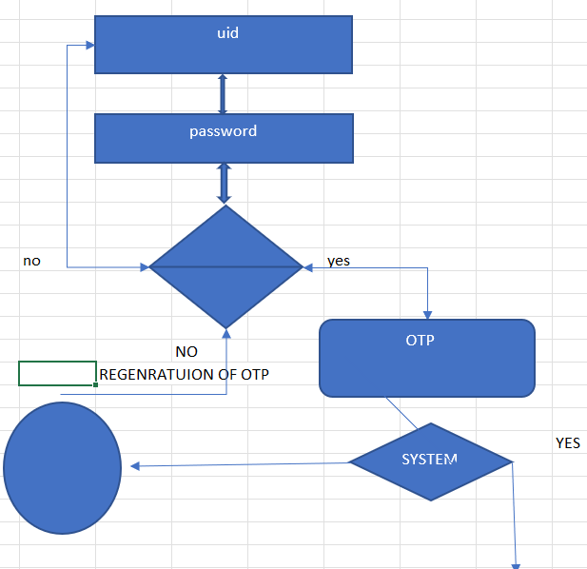

ENIVIORMANTAL: SQL, UNIX, ORACLE, SSIS JSON

PROTOTYPE: A sample model of application without functionality-static image

We use html code



HIGH LEVEL DESIGN: It is also called as external design done by solution designer or project architecture. In this the high-level design deals with macroscopic level

This design defines hierarchy of all possible functionality to be developed as system / component /module

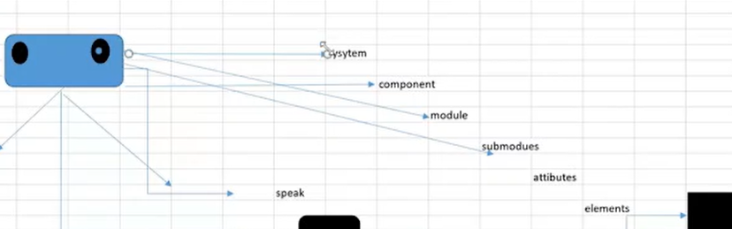

Law level design:

It defines the functional logic of every submodule, e-r (entity-relationship) diagram, class-object diagram, schema design, error message listing

e-r diagram: it is a graphical representation that depicts relationship between object, places, concept, events, properties with types and size within system

* Coding: after the completion of design (law and high level) developer writes the program to physical constructive software w.r.v to costumer requirement with the help of various programming language java, cc+, python

# Testing process workflow:

## .

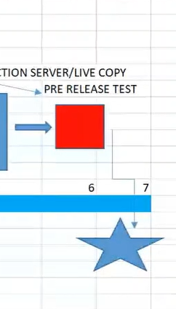

Q) what is mean by SIT and CIT?

Ans= SIT means system integration testing and component integration test

Q) what is mean by UAT AND CAT?

Ans= UAT means user acceptance test and CAT means costumer acceptance test

Traditional project: development + testing + support

Testing: off the shelf

Support: support (PSO)project support office temporary and administrivia support

## Release time:

3 months= quarterly delivery q1, q2, q3, q4 only possible for v and water fall model

1 month= agile

>Entry and exit criteria: exit criteria of design is equal to entry criteria for coding

>Completion of coding is the exit criteria for coding

>Exit criteria of coding is the entry criteria of white box testing

Testing:

Requirement analysis | test scenario design | test case design | review test case | traceability matrix | test execution

Q) what is the difference between test scenario and test case design?

Ans=

Test case are collection of action that are performed to check the functionality

Test scenario is same as use case but describes the situation when user can face while using the app

Entry and exit criteria:

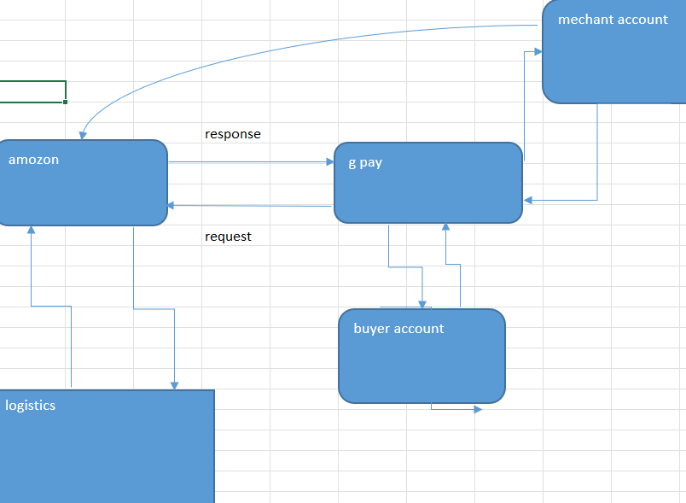

Defect leakage: let us assume during SIT we identify 80 defect and during UIT we identify 30 defects so out of these 30 defects 10 defect are new and 20 defect are existing. These 10 new defects are considered as defect leakage

Q) what is the reason behind the existing defect?

Ans = 1) The modified defect is not saved on server due to this modified defect are not fully implemented on server this is one of the reasons

Q) if in SIT we found 80 defects then why this defect not found by developer during unit testing?

Ans=This is called as gap analysis it is mechanism is used to compare business performance with our desired performance

For example, business performance required 40 defects but actual defect we are getting 50 so we are getting extra 10 defects then

Q) production issue?

Ans= production issue is nothing but after the release of final project into a live environment

At this stage if some issue comes it is called as production issue

Q) what is white box testing log file?

Ans= tester has authority to ask the developer

The log file contains the historical record of an event that occur during test execution as well as during verification

## Environment:

Local BOA/local/host 8000

SIT: BOA/SIT/host 8081

UAT: BOA/UAT/HOST 8082

PP: BOA/PP/HOST 8083

## <HTTPS://WWW.BOA.COM>

## ORGANISATION STRUTURE:

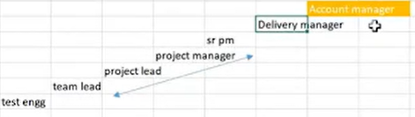

Q) who you used to report?

Ans= I used to report project manager and project lead

## ====================================================================

## PROCESS Implementation:

1. V Model
2. Waterfall model
3. Agile model

V model: v stands for verification and validation

The v- model is an SDLC model where execution process happened in sequential manner in v shape it is also known as verification and validation

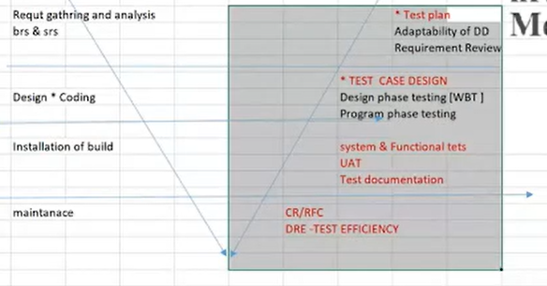

Requirement gathering: SRS and BRS

DD: development document

IMP SCENARIO: In the left hand you are going to play white box testing

Ans = yes because client is going to pay the for what is being done not for who is doing it

Maintenance: if some issue comes then how you deal with

DRE: defect removal efficiency

CR: change requirement

RFC: request for change

Q) what are the advantages and disadvantages of v model?

Ans= Advantages:

1. Testing and development run parallelly
2. Output of the project is good

Disadvantages:

1. It is very costly because for every step client has to pay money only reach client can afford it

DRE: defect removal efficiency/ test efficiency/ defect deficiency / test productivity

DRE= A/ A+B, where a = defect found by SIT =80, and b = defect found by UAT =30

DRE= 80/80+30 = 0.67 it is considered as good efficiency

80/80 = 1 it is called as zero bug density

==================================================================================

Waterfall model: ex master card, American process



It is done in one release and there is no frequent change in requirement and it is done in one tat period and it is also same for v model

Water fall model is also called as linear sequential model

It is very stricter process

In this only first one process is running and remaining became silent at a time work form

It this current stage operation depend on delivery of previous stage operation that means the until the previous process is not complete the next process is not start

Drawbacks:1) it is time consuming process and high-cost model

NOTE: The process implementation purely depends on the nature and behaviour of project and decide by client

Testing on local environment = shift left testing

We perform test on local environment to eliminate the potential defect that means the main objective of the testing is to improvise the standard of code

Q) what do you mean by local environment?

Ans = a local testing environment is place where you can setup a copy of your website that still function like real thing

It provides the space for you to test theme, plugins, updates and anything really before you make alteration to actual site

In v and waterfall model if organisation is unable to full fill all requirement, then organisation has to pay some penalty and if client requires any further requirement in the project in between then client has to pay some extra money

Agile Methodology:



****************************@@@@@@@@@@@@@*******************************

Definition: agile follows iterative and incremental approach

Q) what is iterative?

Ans= same type of process we are repeating, i.e., list of requirements then designs coding and testing same procedure for multiple times

Q) what is incremental?

Ans = incremental means we keep on adding the new features or modules on an existing software

Agile principle:

1. Costumer no need to wait for long time
2. We develop test and release piece of software to the client with few numbers of features
3. We can accept requirement changes
4. There will be good communication between developer, tester and BA
5. Delivery is very fast

Advantages: 1) requirement is allowed at any stage of development, the requirement changes in the middle of development

1. Release will be very fast
2. Costumer no need to wait for long time
3. Good communication between team
4. It is very easy model to adopt
5. We have more no of meetings

Disadvantages:

1. Low focus on design and documentation

Q) what is the difference between scrum and agile?

Ans= scrum is a framework by which we build software product by following agile principle

Agile is a defines process with some defines process and to follow this principal scrum will be used through which we build a software

Scrum team:

Product owner

Scrum master

Development team

QA team (5-9 member)

1. Product owner: 1) actual person who will write the features of the application he is always in contact with costumer and get the inputs and requirement from the costumer. Suppose the application have 100 requirements then product owner will priorities the requirement which requirement should be implemented first

2) If the application is going under some issue, then product owner has a rite to accept the product or to send the application for redevelopment he is the main persons in this process

I.e., accept or reject the work result

B) scrum master: 1) the main role of is facilitating and driving the agile process

2) the scrum master knows every step in agile process, he has to make sure that the development and tester team must follows the agile process properly or not. He will take care of entire agile process from beginning of the process to end of the process and most of the meeting is arranged by the scrum master

Terminology:

1. User story: a feature or a module in software it is a smaller requirement and user story are derived from epic (product owner)
2. Epic: collection of user story it is a larger requirement
3. Product backlogs: contain list of user story. prepared by product owner it is a requirement of application in the form of excel shit or document which contain all the user stories defined by the product owner at the beginning stage of agile process
4. Sprint/ iteration: it is a span of time of to complete user stories means (design, development, testing) it is decided by product owner and team
5. Sprint planning meeting: a meeting conduct with the team to define what can be delivered in the sprint or specific duration. In other word we can say that what are the stories that we have to develop and test and release to the costumer in that particular sprint

In this we have to imp points

1. How many stories we have in the backlog
2. How many stories we are going to develop and test during the sprint
3. What is the duration of sprint
4. Sprint backlogs: list of committed stories by development and QA for specific sprint
5. Scrum meeting: meeting conducted by scrum master everyday 15 min. called a scrum call- or stand-up call

If there are any blocker if there are requirement missing that developer not able do something or tester is not able to do something then scrum master will track the entire agile process. If there any issue or delay we have freely discussed with team in this meeting

There are three main questions that we have to answer it

1. What did you do yesterday?
2. What will you do today?
3. Are there any blockers in your way?

*********************************@@@@@@@@@@@@***************************

This model works on compensation by both client and organisation

Agile is a philosophy. It is a methodology. It is not plan driven it is a value driven, it is cumulative in nature, I mean to say it is frequent in requirement does not have any impact neither on development nor in production not on testing. i.e., The requirement is absolute dynamic by nature

Q) what is value driven?

Ans= At the last day of project if some requirement comes then it should be implemented and there no impact of this requirement on the project overall time it is called as value driven

Definition:

Type of agile:

1. Lean
2. Kanban
3. Dsdn
4. Fdd
5. Xp = extreme programming

Q) for which process are you involved?

Ans= my model is scrum and we are involved in scrum

Q) how much it will take for release?

Ans= it will take 1 month

## Terminology:

* V and waterfall Agile
* Account manager solution manager
* Project manager scrum master
* Stake holder (dm, SPM) stake holder
* Business analyst product owner (collection of list requirement)
* Project requirement (BRS) product backlogs (ok, cancel, delete)
* Release sprint
* Module requirement sprint backlogs (ok)
* Estimation Estimation
* SRS Stories
* Use case acceptance criteria
* Status call scrum meeting

* Solution manager: responsible for channelize the money and cost analysis
* scrum master: define the scope of project, handle the project operations
* stake holder: responsible for to monitor and handle the agile project (dm, spm)
* product owner: collecting the project requirement(backlogs), estimation and design the project and acceptance criteria
* product backlogs: list of requirements to be delivered in the corresponding agile project
* sprint(modules): module to be delivered in the corresponding sprint in the agile project
* Sprint backlogs: the list if requirement to be delivered in the corresponding sprint is known as sprint backlogs
* Estimation: it is a process is a mechanism used for transformation of product backlogs into sprint backlogs
* Stories: defines functional requirement to be developed and system requirement to be used
* Acceptance criteria: it defines business condition
* use case: it defines functionality in terms of input, output and process
* scrum meeting: it is everyday meeting in the agile project

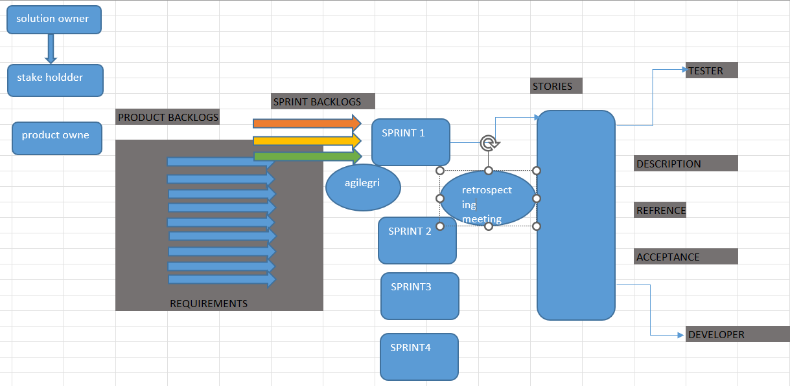

Q) What is flow of agile?

Ans= the first comes solution owner then stack holder come to the picture then product owner collects the list of requirements then estimation process will start, then the sprint backlogs is analysed on to the specific sprint. stories will be design which consist of description reference and acceptance

Agile velocity: agile velocity is guessing mechanism is used to ensure total no of sprint backlogs

To be delivered corresponding agile project

One sprint contains 8- 13 sprint backlogs

AV = total no of sprint backlogs to be delivered in the very first sprint * total no of sprint

Let us assume we delivered 11 sprint backlogs in first sprint

Total no sprint = 7 then AV = 11*7 =77

Burn down chart: This graph shows the pending task with respect to time. This graph is reviewed at every end of the shift. This chart represents time taken by the individual project

Burn up chart: this same as burn down chart but vice versa. This chart represents status of all sprint

It represents planned task vs pending time

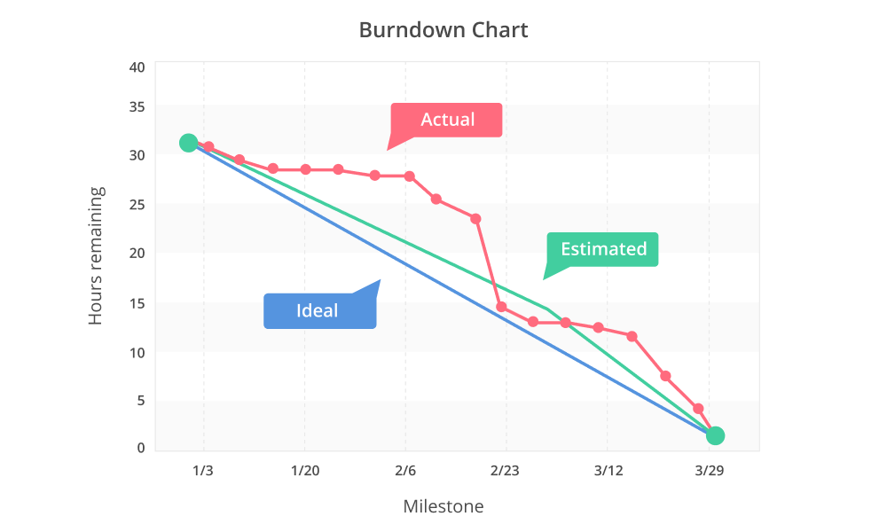

Burn up chart:

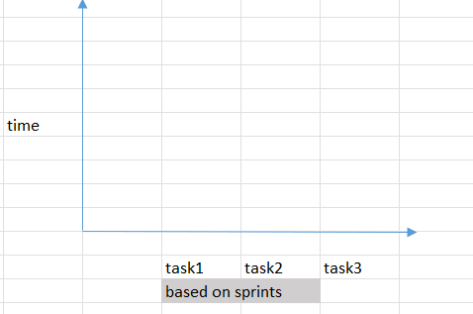

Agile grooming: before start of any sprint the product owner test engineer and developer gathered to analyse the existing requirement to be delivered on corresponding sprint are clean and clear or any modification is there

As the requirement is absolute dynamic in nature so we analyse whether the requirement is clean and clear or any modification is there

Retrospective meeting: After completion of every sprint, we analyse what went wrong and what should be the action next to be taken to improvise the performance

Scrum meeting: (basically at 5.30 to 6.30) everyday stand-up call including developer tester product 0wner

Q) who is the chairperson?

Ans= scrum master

Q) what is the discussion under this meeting?

Ans= 1) what we did

1. what we will do
2. what are the road blocks

NOTE: the scrum meeting establishes the communication and what is the status of the project it will help to improvise the daily basis task to complete with in a given time

Estimation: it is nothing but the list of requirements to be delivered in sprint but which requirement is delivered in which sprint

Generally, we consider three parameters during estimation

1. knowledge
2. effort
3. complexity

vertical or domains:

1. telecom
2. banking
3. insurance
4. payment
5. logistics (e commerce, supply chain)
6. artificial intelligence
7. semiconductor

Q) what is supply chain mechanism?

Ans = the path between manufacturer and end user is known as supply chain

Q) for what purpose the Apache NIFI is used?

Ans = Apache NIFI is integrated data logistics platforms for automating the movement of data between disparate system (data movement from source to target)

Q) what is server?

Ans= server is computer program through which can provide our service to on other end user

Application architecture:

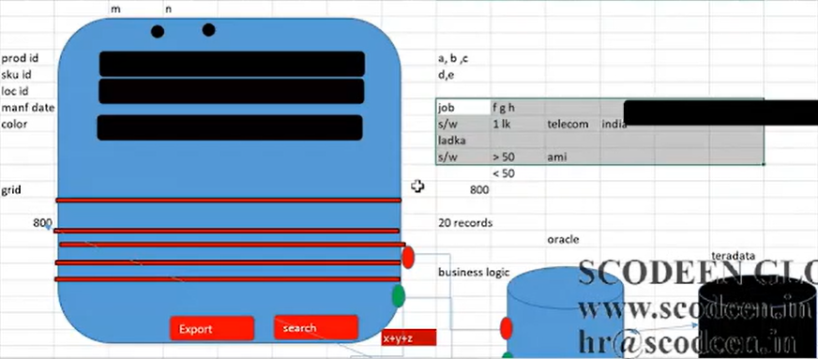

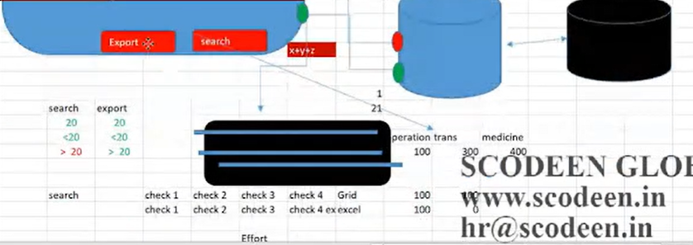

Check points:

Check point it is request and response mechanism bet database and application

Above scenario contain 4 check points

Effort estimation: how much effort is required to develop or maintain

Q) what is the critical scenario you face recently?

Ans= recently one requirement come which is data migration from oracle to Teradata

NOTE: Agile follows two approaches

1. iterative approach:

drawbars:

1. agile oppose System Architecture Integrations
2. agile support client server Architecture only

stories: i.e., nothing but the test cases

Stories definition: A user stories is smallest unit of work in an agile framework

There three parts of user story

1. who wants the functionality
2. what they want
3. why they want

the stories describe a piece of work that needs to be done to complete the project, A project is made up of multiple stories. A sprint is a simply set of duration in a time in which the work will be done in a selected story

Description: As an end user I can able to insert mobile no in address page, which will be stored in container

Definition: general explanation of a software feature written from the perspective of an end user or Costumer

Acceptance criteria: (use case) condition that a software product must meet to be accepted by end user, a costumer or other system. The acceptance criteria are provided by product owner or stake holder

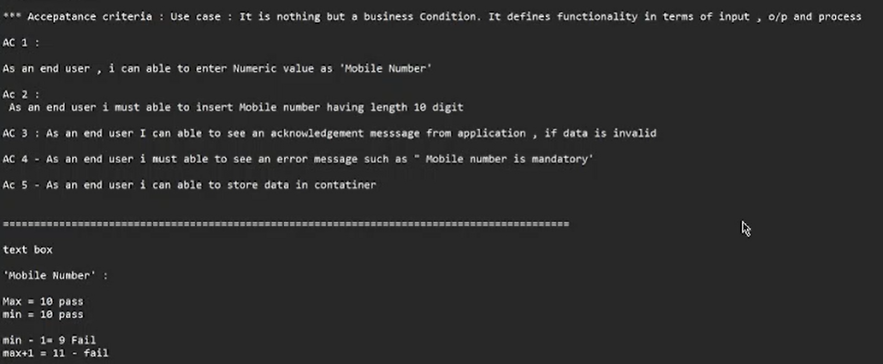

Testing Terminology:

1. Unit testing: it is a part of white box testing

It is also called as component testing / programable testing / module testing / micro testing /structural testing

During this test developer execute the piece of block to check the completeness and correctness of module

1. White box testing: it is categorised into
2. Execution test:

execution of all possible block

Loop coverage [loop termination]

Program technique coverage: program should be written in such way that it will take a smaller number of memories

1. Operation test:

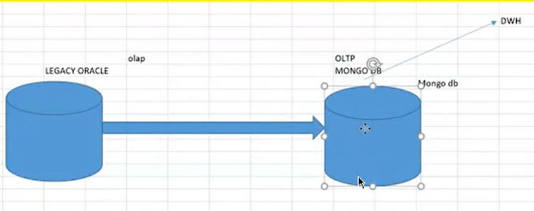

the program must run on costumer expected platforms like browser, OS, mong db, other software

Current data (transaction data) = Mongo DB support dynamic data i.e., OLTP (online transaction processing system)

Historical data (legacy data) oracle i.e., OLAP (online analytical processing system)

The program must support every environment

1. Mutation test: change

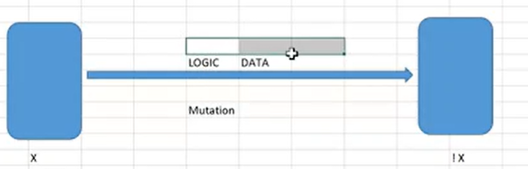

It is a from white box testing in which developer will change specific component of an application’s code to ensure a software test will be able to detect any changes or not

During this test developer intentionally change the data and logic to estimate the coverage in application i.e., application is able to recognise any changes or not

Integration testing: it is a type of software testing in which the different unit, module, component of software is tested as combined entity

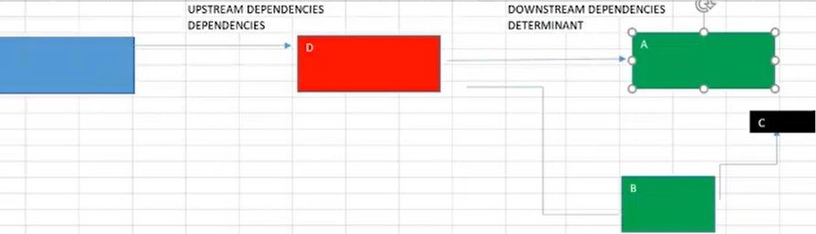

Upstream dependency: An upstream system is any system that send the data to Collaboration server system.

Downstream dependency: A downstream system is any system that receives the data from the collaboration server

After completion of coding developer review and integrate the module, submodule, component with respect to high level design and law level design

Generally, developer integrate the module into a master file using call function

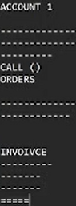

Integration: integration of module, submodule, component, attribute, element with in one system is called as integration test

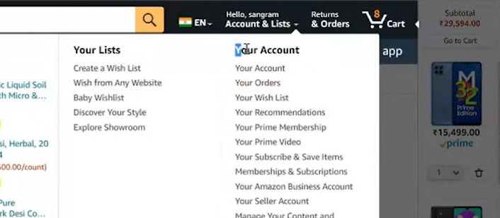

System integration: Integration of two or more than two different system with respect to high level and law level design to derive the function

During system integration test we follow three approaches

1. Top-down approach:

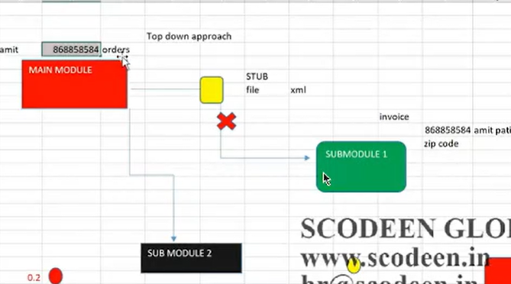

during top-down approach we conduct test on main module instead of coming to submodule which is under constructive or not physically accessible, during this test we implement one temporary program called as stub it is also called as called program

Stub: developer will send to the tester engineer

Xml: extensive mark-up language it consists object and values. it is universal language it helps automated integration testing of messaged based application and data format. The validation of Json, xml and plain text messaging request and response can be performed

One stub for one requirement

Object values

Tags value <price> 66.90

Json: java script object notation

Object values

Key value price :66.90

Object values co-relation theory: in this the value is always in decimal

Price: decimal float

Price: phone no integer

Object -object co-relation theory:

Ex: aid and password

Order id validation project:

Q) can you edit the xml file?

Ans= I can edit the xml file but in notepad ++

After the update of order id, we have to save it in xml format as _r3.0_amazon _Ecomm payment integration_sit_stub order_id_001

Unix:

PuTTY it is terminal for Unix

Q) how you send file to the server?

Ans= with help of Unix and FTP= File transfer protocol

Q) where you use Unix in project?

Ans = 1) to send the file to the server

1. Stub implementation
2. Response file validation
3. Log file validation
4. Server status= means how many hours the server is off
5. Job run = it is a setup file to give the access to other

Access logic:

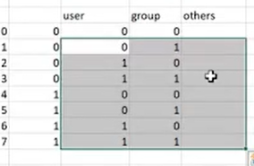

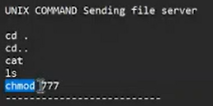

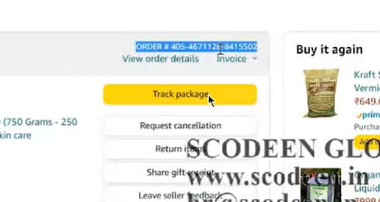

FTP AND HTTP: file transfer protocol and hypertext transfer protocol

https= hypertext transfer protocol secure

FTP:

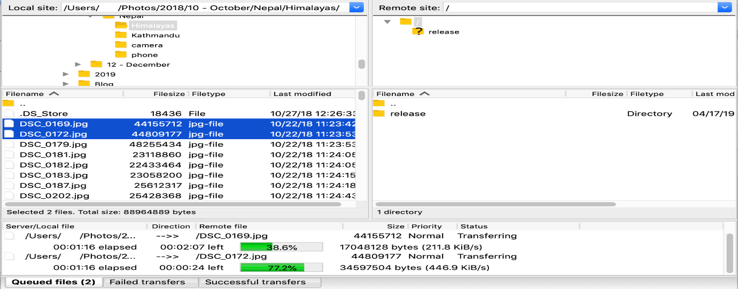

This is an actually a toll We have to just drag and drop into the remote site

===========================================================================

# This part is remaining

===========================================================================

After executing a query of repository file u will get the table of order id and after double click on encoding no you will get XML file and it is same for request file also and this two-xml file should be saved in desktop

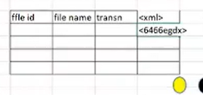

1. database:

select * from request file where file_id = _r3.0_amazon _Ecomm payment integration_sit_stub order_id_001. Resp

select * from repository file where file_id = _r3.0_amazon _Ecomm payment integration_sit_stub order_id_001. Resp

2) repository:

Q) what are the criteria for response and repository file

Ans= we can search the file by using Unix as

File name: _r3.0_amazon _Ecomm payment integration_sit_stub order_id_001. resp

3)Unix command log file validation:

Command sequence:

cd.

cd..

cat

ls

grep

xml parsing: it defines the mapping between request and response file

defects in request and response file:

1. costumer name defect:

request file = Saurav Aja be

response file= Aja be Saurav

The request and response file data are not matching for costumer name please do an appropriate correction

2)subscriber id:

Sub id =A8844894 sub name= T-Mobile

Sub id= 8844894A sub name= T-Mobile

Invalid sub name and sub id in product transaction response file

Sit follows the high-level information

Sum of the network used in USA

1. T-Mobile
2. Verizon
3. Mint-mobile
4. AT&T
5. Google Fi
6. Consumer cellular

Q) how to write the defect?

Ans= The letter A is places at the end of the sub id in response file while in request file it is at the start of the sub id

3)price:

Price= 5.00

Price= 5

Invalid price is displayed in net banking transaction response file

NOTE: all back-end related defect should be considered as critical

Backend: Database, ETL, BI, Bigdata, system integration, API webservice

1. Bottom-up approach:

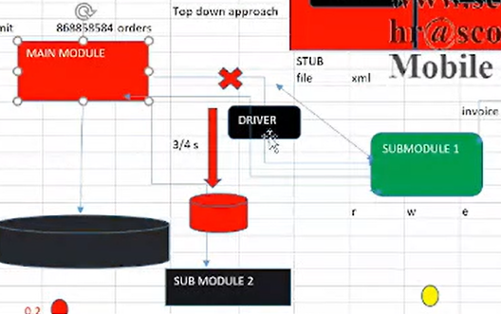

during bottom-up approach we conduct test on submodule / downstream system instead of coming to main module we implement temporary file is known as driver we can call it as calling program

Q) what is the difference between driver and stub?

Ans= Generally what happens once the code is design with respect to HLD and LLD

Developer will integrate the module with respect to LLD, once it is done, they are going to take in master file. After that we are going to start the system integration testing. Then the test team is going to performs the test with respect to HLD AND LLD to validate the functionality. Then test team implement three approaches during the integration test top-down, bottom-up approach and sometime hybrid/ sandwich approach

3)hybrid and sandwich approach or bi-directional approach:

If the system works as module as well as submodule or upstream & downstream, in this scenario we will implement

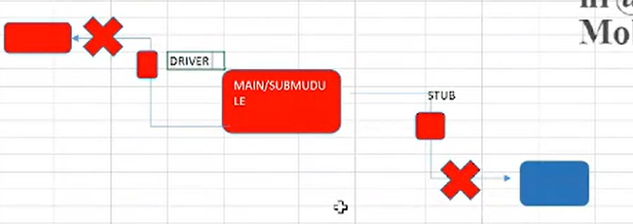

System and Functional testing: after completion of integration,.exe (executable file) copy is created (build)

Once we receive build, we start system and functional test through a set black box testing technique with respect to costumer requirement. This is characterised into four parts

1)Usability test: user friendliness of screen or build /application

1. GUI test:(graphical user interface)

Fine design concept

1 – ease of use: user friendliness of screen/ application

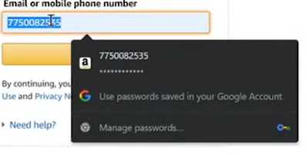

2 – ease of operate: pleasantness and attracted means whenever you entered some data the next icon should be focused

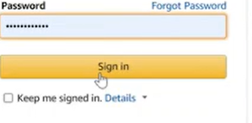

3 – speed of processing: less no of event to complete the task example like what’s app we can share message by just clicking the individual name instead of sending the message for an individual and also in mail the option is given, i.e., reply and reply all

1. Manual support test: context sensitiveness of user manual

Regular expression: some time some object having same logical and physical description to resolve this we use regular expression

Example: [start] [stop] [a-x]* start is common for both and [a-z]* is called regular expression

We cover GUI test during functional test

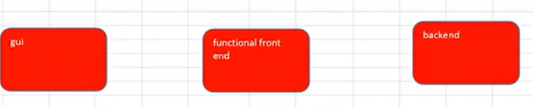

It is done in three environments

Test condition:

Size, font, colour, label name, error message, date format

NOTE: all GUI related defect consider as law and medium priority, generally client responsible for the GUI design if IT Department is strong then they will decide the design if it is not then organisation takes the responsibility

Q) what is Microsoft six rules?

Microsoft six rules:

1. Control are iniit cap (initial letter must be in capital letter)
2. Controls are visible (font size must be even)
3. Controls should be aligned (alignment)
4. Controls should not be overlapped
5. Ok and cancel existence
6. System menu existence

Functional test: it is measure part of black box testing

During this test we validate functionality of the system with respect to costumer requirement

It is also called as requirement testing

It is characterised into

1. Functionality: during this test on concentrate on various coverages
2. Behavioural coverage: [to check the properties of object]

Object properties

Text box enabled /disabled / focus / unfocused

Q) what is the difference between list box and combo box?

Ans= 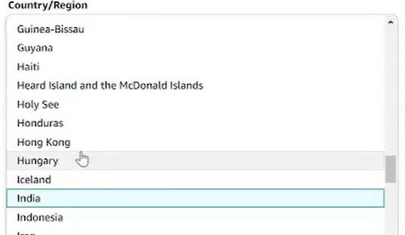

combo box= it is single element dropdown

Text box= It is nothing but dropdown where we can select multiple option like filter in flip cart

properties: enabled /disabled

Radio button:

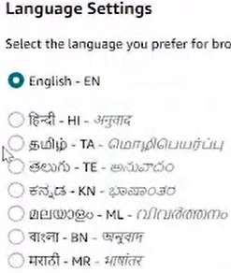

properties: on and off

check box:

properties: check and uncheck

button:

properties: focus and unfocused

1. Input domain coverage:

Boundary value analysis (VBA):

----------------------------------------------------

Origination min destination max

Suppose:

Costumer name length is 4 - 13

Min = 4 pass

Max = 13 pass

Min-1 = 3 fails

Min+1= 5 pass

Max+1=14 fails

Max-1 =12 pass

Nature of data:

Static data= product id, roll no, order id for this the length is constant

Dynamic data= product name, costumer name

Equivalence class partition: (ECP)

Note: in back end the min value in terms of length of data is not considered only max value is considered

We validate the data by the concept, I.e., ECP & VBA

A – Z alphabets uppercase

a – z alphabets lowercase

0 – 9 numeric

Space

Special character

These 5 scenarios are pass then and then there no defects, these 5 rules we can apply in terms of integer value also

This 5 and BVA 6 condition is the universal validation technique

Q) in an application end user required user id and password to login the system user id consist 4 to 8 alphanumeric and password consist 4 – 13 alphanumeric please design VBA & ECP?

Ans=

1. User id BVA

Min = 4 pass

Max = 8 pass

Min-1 = 3 fails

Min+1= 5 pass

Max-1 = 7 passes

Max +1= 9 fails

B) Password ECP

Valid invalid

A – Z special character

a – z space

0 - 9 blank

Password VBA & ECP:

1. Error handling coverage: [preventing negative navigation]

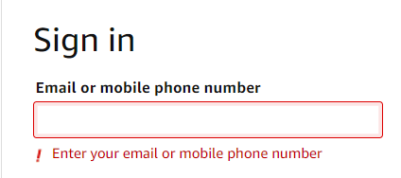

We have to ask the BA to provide the error list then we will provide us the list of error

1. Backend coverage: [impact of content with respect to operation]

**LENGTH DATATYPES MANDOTORY CONSTRINT NULLABLE**

**CELL NO 10 INT YES/NO PK/FK NO**

**PRODUCT ID 20 VARCHAR YES/NO PK/FK NO**

**COSTUMER NAME 20 VARCHAR YES/NO PK/FK NO**

We can define primary key on static data only

Q) what is the difference between varchar and varchar (2)?

Ans= varchar supports static data while varchar (2) supports dynamic data

Q) what things you validate in the database?

Ans= 1) Table structure validation

2)Length

3)Data type

4)Constraint

5)Mandatory

6) Nullable

Schema validation: (mapping testing) mapping testing between front end and back end

Store procedure validation:

Trigger

View

Database server validation: on Unix

It will maintain the record in UNIX how much time the server is active or inactive

Performance testing:

Performance testing include testing Scenario like, consider an example like E-COOMERCE Website amazon in this product delivery status is maintain as below

Process status

Initiated I

Payment done P

Dispatch D

Delivered DE

In this the most common defect is that the product status is getting change in front end but there no changes in the status at the backend

How to check the status of each process?

Ans = by running simple SQL query

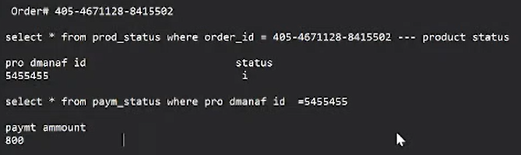

Q) what is structure validation?

Ans= We have to analyse the measure concept of the nature of the data, i.e., static or dynamic that will gives us the structure validation

1. Service level coverage: [order / sequence of functionality] means sequence of functionality it is design by BA

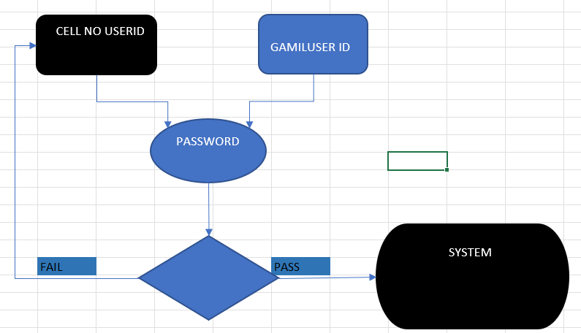

Q) have you involved in service level coverage?

Ans= yes, at the time of system integration architecture and functional test i.e., order of functionality (entry exit criteria)

Calculation based coverage: [arithmetic logic] for this we use NumPy library in python

Calculation based coverage means how much will be the unit price, net amount, QTY, tax rate, tax amount and total amount

# No functionality

a) Recovery test

b) compatibility

c) configuration test

d) intersystem system

e) installation test

f) parallel test I never had chance

h) sanitation test

g) globalisation

1. Recovery test: it is mostly used in payment method

Abnormal testing: card – password—1000—saving account—print – withdraw

Event start ----------------------------------------------------------------------------------event end

Rollback mechanism: it is also kwon as reliability test, during this test we validate the recovery of application from abnormal state to normal state

To validate the functionality, we have to come across the various event, if any abnormal situations occur in bet event 1 and the event- end then the system has tendency to follow roll back mechanism

Example of abnormal condition:

Server slow, power down, system crash

Project on recovery test:

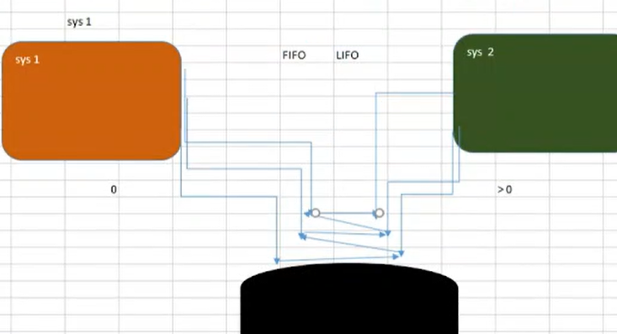

FIFO = First in first out

LIFO = Last in first out

Test cases=

System 1 request 1 = 5 min

System 1 request 1 <5

System 1 request 1 >5

System 2 request 1 =5

System 2 request 1 >5

System 2 request 1 < 5

Q) How the test cases are executed?

Ans=

Inter Q) tell me the scenario where you face the challenge?

Ans = recently we got a requirement, what happen in that case two system share one comment database the requirement was every request will take 5 min and system1 request 1 – system 2 request 1 will process generally we use FIFO Algorithm to resolve the queries, we identify various condition

The one challenging scenario is that what if system 1 request 1 and system 2 request 1 will come simultaneously it is depend on AI

We solve this with the help of developer, tester and platform team with discussion

b) Compatibility: there are three types of compatibility test

1) language compatibility test (globalisation test)

2) hardware compatibility test (configuration test)

3) software compatibility test

Compatibility test is also called as portability test:

During this test we validate the compatibility of our application with costumer expected platform

Costumer expected platform means OS, browser and other operating system genially it is of two types

1. Forword: If the issue belongs to costumer expected platform is called as forward compatibility test (system software, OS)

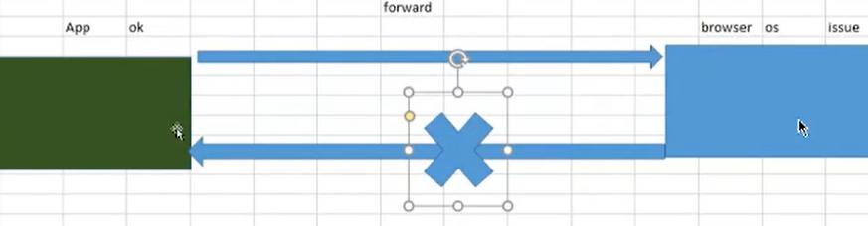

1. Backword: If the issue belongs to an application, then it is called as backward compatibility test

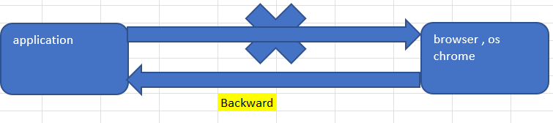

Generally, we found backward compatibility test as maximum

Q) in which scenario you involved?

Ans= that rime I involved in browser compatibility test

Browser compatibility test categorised into two parts

1. Cross browsing: application should be run on browser, chrome, internet explorer
2. Version comparison: it means the application should be run on different version on same platform

Q) how to raise defect?

Ans= R3.0_compatibility test_SIT_defect_id_3423

During this test we cover

1. Hyperlink accessibility
2. Page navigation
3. Tab validation
4. Interface validation
5. Performance testing
6. Session
7. Cookies

Q) which type of test done by developer?

Ans= execution test, operation test, mutation test

3)configuration test (hardware compatibility test):

During this test we validate the compatibility of our application with hardware devices

Ex = Microsoft 2008 supports laser printer but doesn’t support dot matrix printer

Project related info

Lan = local area network

Wan = wide area network

Man = metro area network

Topologies: (architecture framework)

Standalone, ring, tree, mesh

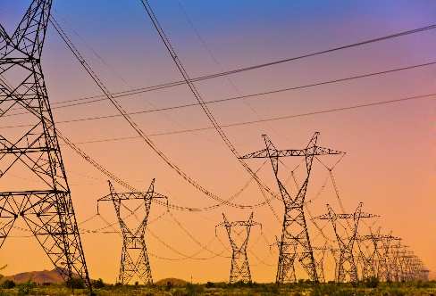

In terms of network like 4g, 5g

Switches, routers, hub

Intersystem test: coexistence of our application along with other existing software to share the information or resources along with associated subsystem with help of file handling mechanism

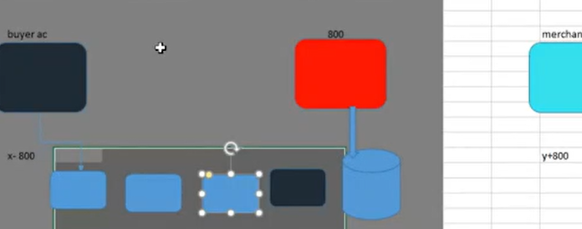

The subsystem is nothing but different IT sector

Q) which scenario are you involved?

Ans= sir I had involved in database, ETL, big data and EDI file handling process

File = CSV, Flat file, EDI ( Electronic data interchange)

Advantages= 1) Less cost

2)Secure

EDI architecture:

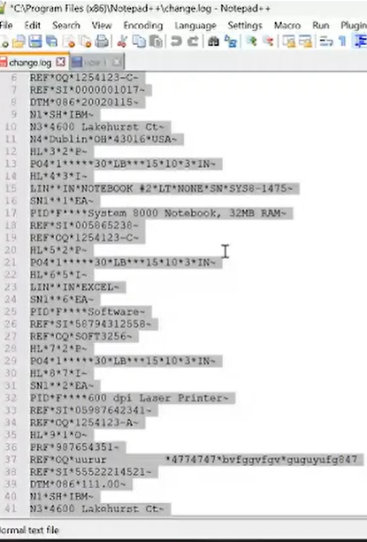

1. Values are shape rated with *
2. It consists segment = it is like1) price = 20.12, 5.0, 50 which hold different price it is called as price 2) TRN means transaction which holds different ID NUMBER
3. It consists data element: The object contained different values are called as data element

Framework: we get shape rate EDI file every time for every function

ISA = interchange control file: had office: Pune | city code = 561511

GS = functional group header: which company: IT | Location = India

ST = state transaction header

NM = name segment (company name, city name, hospital name) (payloads)

SE = state transaction tailer

GE = functional group tailer

IEA = interchange control tailer

## File handling mechanism and validation:

Control validation:

Data manipulation | data intelligence

Edit the file?

Ans= 1) Implementation of data intelligence

2)send the file to the server (by Unix)

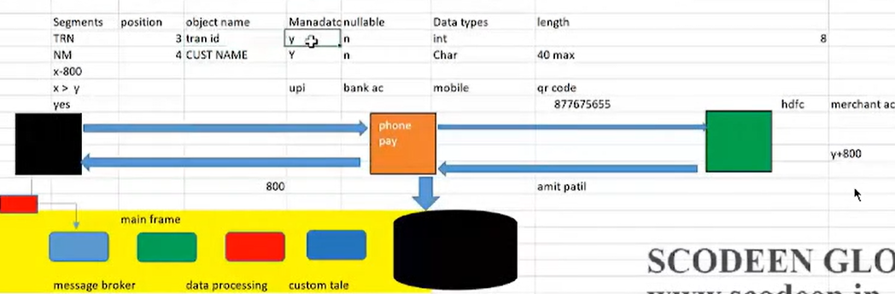

Inbound process

Process: the EDI file will pass through every server and if there any defect it will stop, suppose if we have transaction id of and costumer this transaction id should be replicate in the database. every data should be as per requirement. if in the data as par requirement then data must be also correct in sub-system like message broker, main frame, data processing, custom table so we have to test data in final data base rather than checking the data in subsystem

Q) what Is the challenging area in inter system test?

Ans= implementation of EDI file processing.

Q) why?

Ans = data intelligence is the most critical task, the small mistake can create the massive impact

Q) how to say this in an interview?

Ans = there are CRN system and the other one is billing system we are using one intermediate application uniped billing system, generally we process a file in the file generally we implement

Data intelligence that data with respect to costumer requirement moves through server like

message broker, main frame, data processing, custom table after that the data get loaded into server and we validate the data with respect to business logic the data structure is defined as per requirement or not

message broker: it will tokenise the data, it means the data in the file present in the form of lines

so, it will break into pieces

installation test:

CRM application

The installation test is done on live environment, i.e., is called as pre-production environment not on local environment

Steps involved in installation test an application

1. Setup program execution before installation (.exe)
2. Easy interface
3. Occupies diskspace after installation
4. Uninstallation and post installation process

Parallel test: comparison test

This Is applicable for product

Application v/s product

Product: product means multiple clients can use like google pay, phone pay

Amdocs, BMC, Ericsson, cisco

Application: It is specially design for client only

Infosys, TCS, Capgemini

During this test we compare our application with competitive existing product in market

## Globalisation | internationalisation | localisation: language compatibility test

English French, Russia Marathi

Q) what should you talk if interviewer ask you about the language compatibility test?

Ans= one of the scenarios I come across is that my client wants to deploy the application in the southern Canada and I have involved in the English and Espanola (Spanish)

During this test we check whether the application supports multi linguistics character or not

During this test we concentrate on

1. Interface validation: interface validation means the application validate the data that is entered in user interface and the application validate the data as per datatype mapping of an input
2. Link accessibility
3. Tab validation
4. Performance
5. Functionality validation

Requirement: end user used will see French as hyperlinked

As per the language the date format also changes this Is requirement

Sanitation test: (garbage)

During this test we identify extra feature present in the system, because such that during enhancement (future requirement) client might approach for modification such that organisation generate more revenue

Security test: (high critical defect) All defect belongs to security testing should be consider as high critical defect

During this test we validate the privacy to user operations

It is characterised into

1. Authorisation: during this test we validate whether the user is valid or not
2. Access control: (role-based access control system) whether the specific user has permission to access the application or not
3. Encryption/ decryption: data conversion between client and server

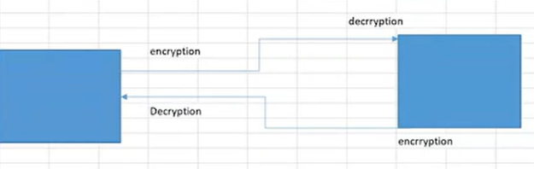

Client

Q) on which part are you involved in security testing?

Ans = sir I have involved in roll base access security testing

application User super user admin super admin

app 1 yes yes yes yes

app 2 yes yes yes yes

app 3 yes yes yes yes

app 4 yes yes yes yes

app 5 yes yes yes yes

app 6 yes yes yes yes

app 7 No yes yes yes

app 8 No yes yes yes

app 9 No No yes yes

app 10 No No No yes

for this we have to ask the developer to send the credential

front end testing will be done by simply log in an application with the help of credentials and at the back end the testing will done by writing a query: select * from

that means we have to validate the front end and backend

Generally, we perform security testing with respect to front end accessibility and back-end flag value validation

To show the proof that you have test this application we have to take a screen shot of the application after a successful login and the back-end also

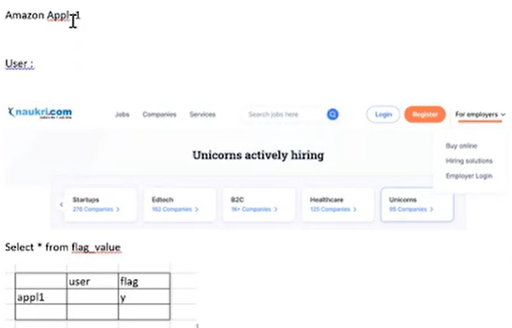

Performance test: during this test we validate the speed of process

It depends on below factors:

1. Front end wrong logic
2. No of user
3. Declaration of class and object
4. Schema validation like state and country 1: many relationship

Shortest path detection: some time we have multiple dimension table and we need to search some specific data and to minimize the execution process this mechanism is called as shortest path detection

We cannot conduct load, stress and endurance test manually because of huge requirement

Load testing: the execution of our application under costumer expected load and configuration (related to network) to estimate performance is called as load testing.

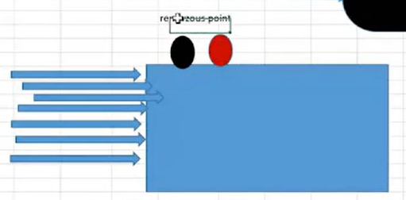

Generally, in load testing we test performance of an application with help of rendezvous point in that we are going to observe the performance graph on the basis of that we will test the performance of an application

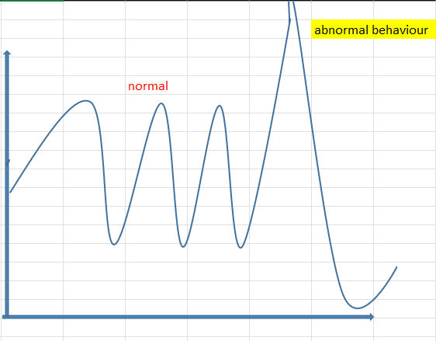

Toll: load runner, j meter

Stress testing:

Storage testing:

Data volume:

Endurance:

The name in red colour cannot be done manually

Stress test: The main objective of stress test is to identify the break event point or threshold point

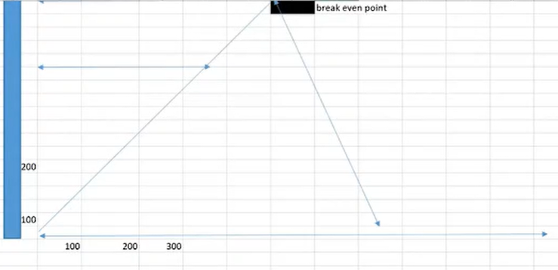

Q) if load testing satisfies the costumer requirement, then what is the significance of stress testing?

Ans= for future / enhancement purpose client must aware the threshold point

The execution of our application under costumer expected load, peak load and costumer expected configuration

Endurance test: during this test we test how much time the application bares the costumer expected load

Generally, memory consummation is considered, to determine the potential failure / crash

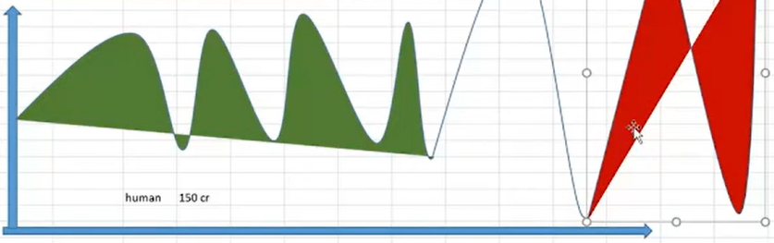

What is the difference between storage and data volume test?

Ans= volume testing is the software testing performed to test the system under huge data load

Data volume test: it is also known as flood test, during this test we analyse the system performance by increasing or decreasing the volume of the database

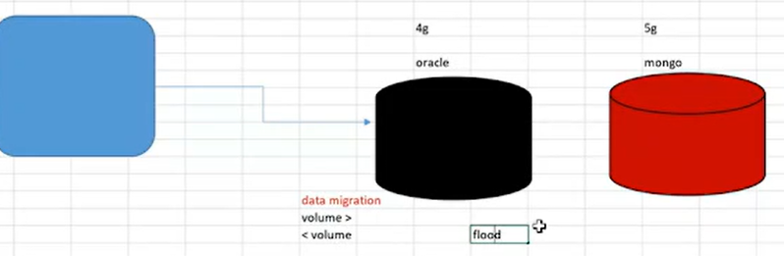

Generally, we focus on response time during volume test and system behaviour

Storage test: during storage testing we concentrate on

1. Relevant information / data is getting stored on specific directories
2. Availability of disk space (lack of space can be the reason of unexpected termination)

Defect: mistake in the code

Error: due to this mismatch occur is called as defect

Bug: when this defect is accepted by developer is called as bug

Issue: defect is called as issue

Known issue: the issue which is already existed due to some environment factors

## User acceptance test:

Q) what is the difference between SIT & UAT?

ANS =

SIT UAT

Primary secondary

High level mechanism low level mechanism

How to write the test case How to write the test case

Enter valid credential enter valid user id

Click in ok enter valid password

End user must be able to access the system click on ok button

End user must be able to access the system

Successful message should be displayed

Costumer involvement is not mandatory costumer involvement is mandatory

The main difference is that UAT represent the testing whether the application meets the business needs and

SIT represent the testing of an application to ensure it meets the engineering specification

Q) what is the difference between beta and alpha test?

Ans =

Alpha Beta

Applicable for application applicable for product

It will be tested by real costumer it will be tested by costumer side, like people

It is tested at development environment it will tested at costumer like environment

## Confidence test/ pre-production test/ final regression / pre realise test / post-mortem test:

After completion of UAT we concentrate on final regression …

For this we create a relies team

Q) what is realise team?

Ans= some developer tester BA are involved

During this test we concentrate on critical area of system (banking / transaction and security)

1. Overall functionality
2. Input device handling (keyboard, mouse)
3. Output device handling (monitor)
4. o/s browser handling
5. environmental

Q) what is mean by KT?

Ans= KT means knowledge transfer

After completion of product deployment or post realise, we give KT to client and we define the functional flow with help of power point slide show and in that we explain the functional flow of functionality or project requirement

If the there is some mistake by pre-production team, then it is called as production issue

If the issue is by client side or any changing requirement then it is called as change requirement

Production issue:

A) PRE PRODCUTION-ISSUE:

Q) what is mean by known issue?

Ans – the issue which is already exist in the system generally due to environmental factors It is called as known issue

Organisation: after build gets deployed into production stage if an issue and it should be valid production issue

Change request: if any customer request comes during execution or post production is called as change request / ticket / RFC

Production issue missing functionality impact analysis

Modification of code test software change

Hot fix mechanism: after the post deployment if the any missing functionality is there then we analyse the impact and modify the code and we re-test it this process called as hot fix module

This process id done by CCB team (change control board) it consists of (BA + TEST ENGINEER + DEVELOPER) the CCB team comes under the configuration management

1. POST PRODUCTION ISSUE (Enhancement)

Production issue enhancement functionality impact analysis Modification of code test software change

### configuration management: to handle the change request during test execution

testing terminology:

1. Monkey testing: availability of ask is more and time to be complete the task is less

During this monkey test we concentrate on conducting measure high priority test case

Test case

1. Gorilla test: it is also called as flood testing and frustration testing

In this we perform test same module repetitively more than 100 times with same input with same test to ensure to remove all the defect even single defect can’t be left

1. Exploratory testing: level by level functionality coverage is called as exploratory testing

Q) if you do not have sufficient knowledge on domain?

Q) what is ad hoc test?

Ans = if you don’t have sufficient test data, then I will implement ad hoc test with respect to

our past experience

Build Architexure:

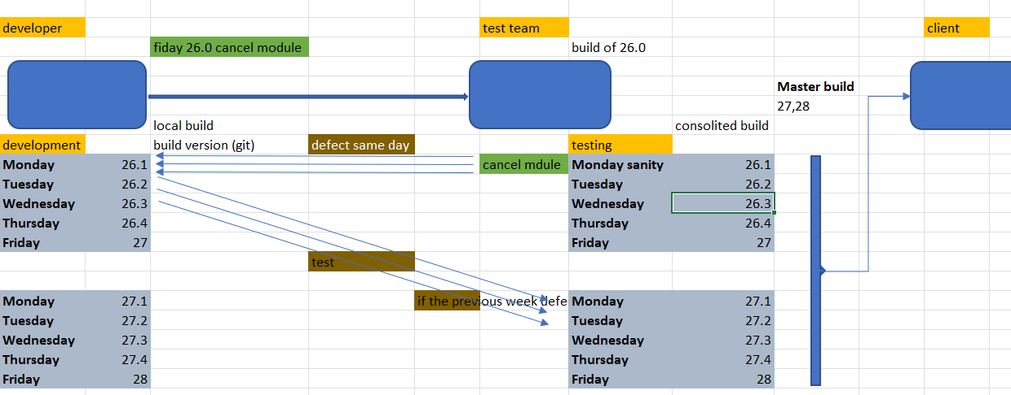

Q) how you get the build?

We get the Build in the form .exe format through FTP server this .exe file they will send to server and they will provide and IP address which is present in soft base server

How you get to know the application is present in which build line?

Ans = the application present which build line we can simple access the database

Ex = select * from build version where application name is update or we can find it by latest version

Blocker defect is found then business can’t wait 7 days

Ex = if the transaction id not generated it is high critical defect

Sanity testing (only Monday): stability testing/ health check-up / build verification testing/ tester acceptance test/ testability/ octangle

During this test we concentrate on stability of build. I mean to say the build is ready for test or not

Generally, we find environmental related defect as maximum

Generally, we cover and basic functionality of system

* Hyper link accessibility
* Interface validation
* Performance
* Cookies
* Session

Q) do you write test cases for it, if you are doing test in one day?

Ans =basic functionality of any system is constant in nature. It means we don’t need to write test cases again and again. It means we write test case during initial stages of system design. We only execute the application during sanity testing

Ex: product selection, payment, product delivery, invoice generation

DLL file missing, run time error, 404 issue

We also find some functional defect but we manage it internally

Front end system:

* Core functionality
* Interface validation
* Hyperlink accessibility
* Performance

How to send professional mail

To [montuGhhosh@gmil.com](mailto:montuGhhosh@gmil.com)(client)

Cc: DM, SPM, PM, BA, TEST TEAM, DEV TEAM

Subject: R.4.0_sanity test_report_sit_build 26.0

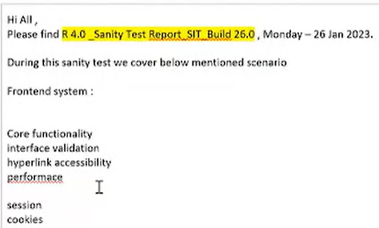

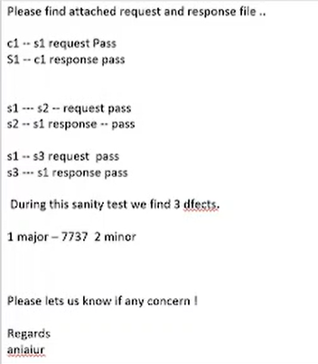

6 pm email

Sanity system integration:

Smoke testing: once we receive the build in this, we are going to check the stability and troubleshoot means package validation

During this test we concentrate on troubleshoot of application when our build is not work, I mean to say if any issue is identified we try to identify where the exact issue

It means to concentrate on package validation during smoke testing

Build upgradation activities:

Compilation process: The build is generated after the database is synchronised on the server

It is done by platform team or database administration team or enviourenmental team this process will take 30 min for data synchronisation

How to send mail to platform team for data upgradation request

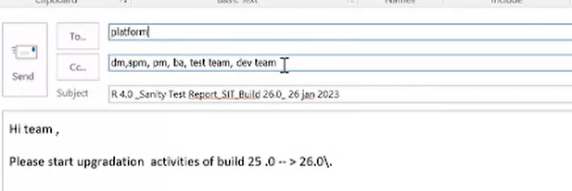

Package is nothing but the interdependent object is created by platform team

Account_001 pkg.

Amozon_account.py

* Country(object)
* State (object)

Amozon_order.py

* Country(object)
* State (object)

This object is gotten synchronised with server with help if Unix, the object synchronisation means they will synchronise the whole package after compilation process is done then log file get generated which is in terms of valid and invalid this invalid and valid file is send to the test team

We receive valid and invalid object via notepad

The invalid object we are going to identify where is the exact issue in the package observe and request to platform team to recompile it

We receive the build via mail the IP Address is provided through mail

We have to also identify this object belong to which package

Q) what is package validation?

Ans = package validation is nothing but object complication mechanism, assume during execution we have find some issue then we have to identify that object is belong to which package and we request to platform team to recompile the package

Big bang testing:/ formal test

one big shot I mean to say during this test we concentrate on a major functionality from start to end, after completion of entire system development process

log in product selection transaction order delivery invoice download

Incremental test: / formal test

Functionality coverage from unit level to system level (level by level coverage)

Re testing: repeated testing with multiple dimension

Re-execution of our application or system on the same build with set of multiple data inputs to validate the functionality with respect to customer requirement

I mean to say we implement multiple dimensions data analytics. It is approach validate the functionality. I mean to say data intelligence

Regression test:

Suppose if build is hand over to tester by the developer team, if we got some defect then we raise defect if it is accepted by developer then they will consider it as bug. After they fix this bug the SIT Team never test it second time. This can happen in UIT testing but not in SIT

Regression plus action

Re-execution of our application or system on modified build to check bug fix work and occurrence of side effects

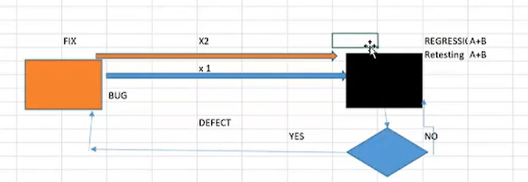

I mean to say once we receive the initial build, we perform retest, if we find any defect then we send the defect to developer

Once we receive the modified build we perform regression test to ensure the existing defect gets fix or not, any side effects are there

Generally, we perform twice in every test life cycle

* During compressive test
* Post SIT

During regression test we concentrate on

SIT failed case

High priority test case

Newly added functionality

If time permits (independent test case)

Automation:

Q) when would prefer to test automate?

Ans=

possibility:

not possibility:

in common testing practice we prefer to test automate with respect to test impact and criticality

test impact means test repetition and criticality means and complex apply test manually

if we apply automation then advantages will be:

* less resource utilisation
* avoid human error
* less time

Q) where you involved in automation?

Ans = I have involved in complex Jason file and set automation using ML and data analytical process

Q) can please elaborate it?

I have involved in ETL functions

* Count
* Length (max and min)
* Source target mapping
* Source target count

Lambda function: (anonyms) higher order function (map, reduce, filter)

In this lambda function the argument will be considered as function

Function calls the argument as function

Server architecture:

1. Standalone architecture: same system with same server
2. Client server architecture: it is divided into three types that is
3. Tier 1: it means database and user interface with a single system it is also called as client tier architecture
4. Tier 2: it means two layer that is client (application, user, API) layer and database layer

client

client

Client

Database

1. Tier 3: it means three layer that is user interface, application server or business layer and database

Client 3

Client 2

Clinet1

**Webserver**

Business logic/ application server serversersersersessssssetserserserver

**Oracle**

Database

If front end is .net, then IIS internet information service

If front end is java, then WebLogic

Nth tier means there are multiple webserver

<https://wpms.concentrix.com>

domain extension

http: hypertext transfer protocol

https: hypertext transfer protocol secure

web service testing: API Testing (application interface programming)

web based testing:

* interface validation
* hyperlink accessibility
* tab validation
* page navigation
* performance
* session
* cookies

security:

1. cookies: whenever we execute any web application the log file is generated at two different places that is temporary and, on the server (permanent)

and the temporary log file is called as cookies.

1. session: the tine gap between event 1 and event 2 in any web application, is called as session

SQL injection: (for hacking) it is mechanism is used for security purpose out of thousand probability concepts one will be true

This program we will execute via web application that attack the database